**Assisted Practice: 3.6 Detach an EBS Volume**

**Step 3.6.1:** Selecting the EBS volume you want to detach

* Choose the bucket

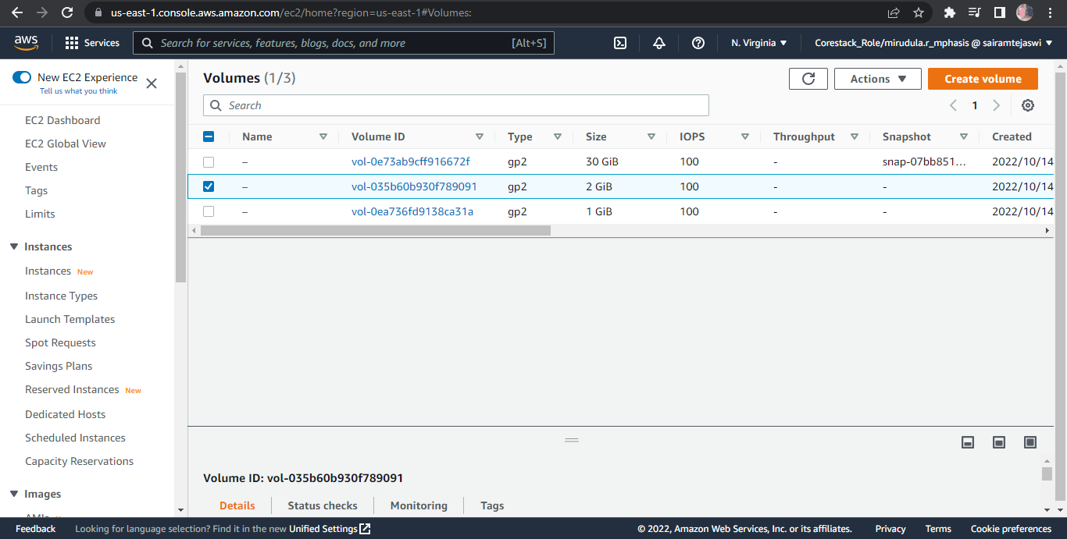

* Select *Detach Volume* option

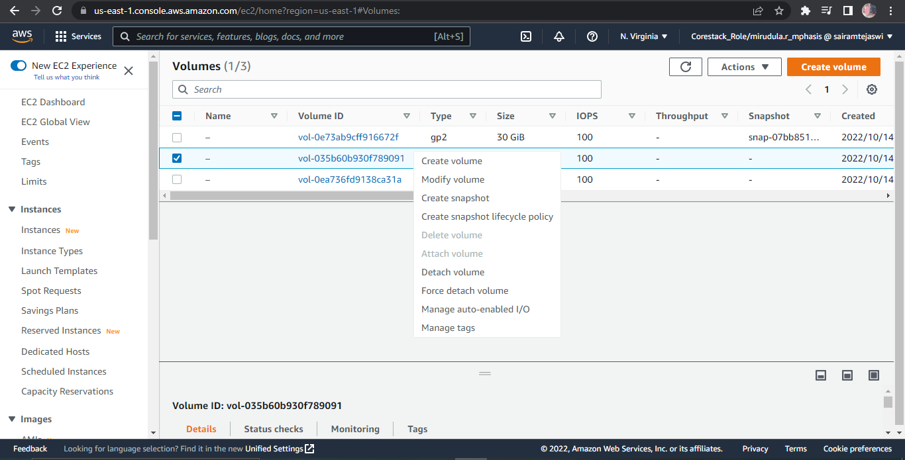

**Step 3.6.2:** Detaching the volume

* Select *Yes* once the confirmation pop-up appears

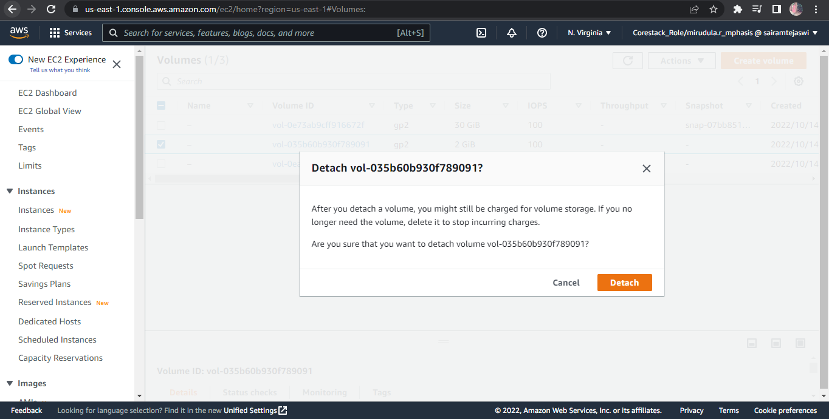

* Once detached, the volume will be labeled as *Available*

